**Microprocessor and Interfacing – CSE2006**

**Module 6 – Coprocessor**

1. **Introduction to 8087**

**Compatible Processors and Coprocessor**

**Processors**

1. 8086 & 8088

2. 80286

3. 80386DX

4. 80386SX

5. 80486DX

6. 80486SX

**Coprocessors**

1. 8087

2. 80287,80287XL

3. 80287,80387DX

4. 80387SX

6. 80487SX

**Introduction**

INTEL designed the first Math Co-Processor to perform 16-bit processes. This was built specifically to pair and work with 8086 and 8088 microprocessors. There would be lot of floating-point calculations involved in any math process and hence to perform these efficiently, the 8087 co-processor was introduced. Simple arithmetic operations such as addition, subtraction, multiplication and division care carried out by the 8086 processor itself and they are not the job of the advanced co-processor. The co-processor is dedicated to perform advanced scientific calculations and complex algebraic functions.

If there is an extra co-processor to perform all the floating-point operations, then the CPU can be free from all these chores. This allows the CPU to focus on its other tasks that are intended to be performed by the CPU alone. Since time and workload sharing is done among the CPU and co-processor, time consumption is reduced to a greater extend.

The 8087 co-processor has around 60 new instructions that the user can make use of. In order to differentiate between the 8086 and 8087 instruction sets, the mnemonics begin with ‘F’. E.g., 8087 instruction for multiplication and division are FMUL and FDIV.

* Other names of the math co-processor 8087 are the following
  + Numeric Processor Extension (NPX)
  + Numeric Data Processor (NDP)
  + Floating Point Unit (FPU)

8087 Math Co-Processor   
40 pin ceramic DIP

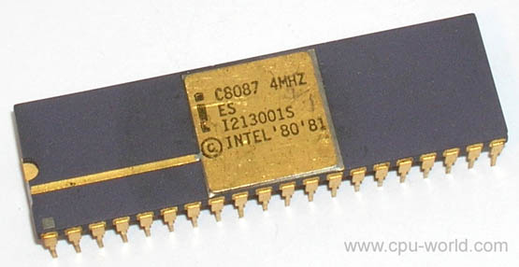

[Source:](http://www.cpu-world.com/CPUs/8087/MANUF-Intel.html)

<http://www.cpu-world.com/CPUs/8087/MANUF-Intel.html> as on 08 Jul 2020

8087 Math Co-Processor   
40 pin ceramic DIP

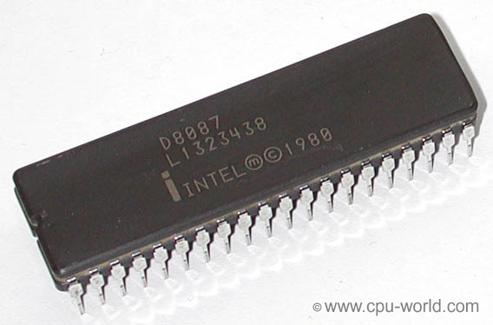

[Source:](http://www.cpu-world.com/CPUs/8087/MANUF-Intel.html)

<http://www.cpu-world.com/CPUs/8087/MANUF-Intel.html> as on 08 Jul 2020